Dependent-Samples t-Test – Example 1 (Pigeon’s Schedule of Reinforcement) ANSWER KEY

Research Question: Which reinforcement schedule elicits more correct responses from pigeons? There are a total of 16 pigeons from 8 clutches (2 pigeons from each clutch). From each clutch, 1 pigeon is assigned to reinforcement schedule A and 1 is assigned to schedule B

Step 1. State your hypotheses.
a. Is it a one-tailed or two-tailed test? Two-tailed

b. Research hypotheses
Alternative hypothesis: Pigeons in condition A will differ in the number of correct
responses from pigeons in condition B.

Null hypothesis: Pigeons in condition A will not differ in the number of correct
responses from pigeons in condition B.

c. Statistical hypotheses
H_{A}: µ_{D} ≠ 0

H₀: µ_{D} = 0

Step 2. Set the significance level ➔ α = .05 Determine t_{crit}. df = 7 t_{crit} = +2.365

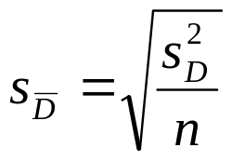Step 3. Select and compute the appropriate statistical test.
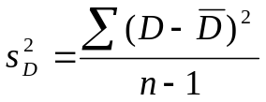
Schedule A | Schedule B | D | 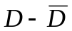 | 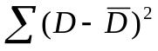
6 | 4 | 2 | .75 | .563
8 | 6 | 2 | .75 | 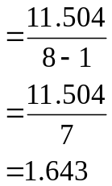.563
5 | 2 | 3 | 1.75 | 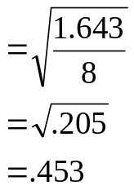3.063
7 | 6 | 1 | -.25 | .063
5 | 3 | 2 | .75 | .563
7 | 6 | 1 | -.25 | .063
5 | 6 | -1 | -2.25 | 5.063
7 | 7 | 0 | -1.25 | 1.563
ΣX = 50 | ΣX = 40 | 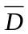ΣD = 10 |  | = 11.504
= 6.25 | = 5 | = 1.25

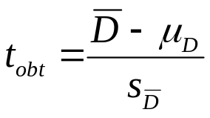

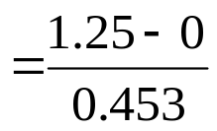

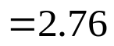

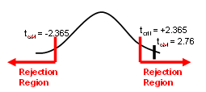
Step 4. Make a decision. Determine whether the value of the test statistic is in the critical region. Draw a picture. Label t_{crit} and t_{obt}.
Is z_{obt} in the critical region? Yes
Should you reject or retain the H₀? Reject

Step 5. Report the statistical results.

t(7) = 2.76, p < .05

Step 6. Write a conclusion in APA style.

Pigeons in condition A (M = 6.25) made significantly more correct responses than pigeons in condition B (M = 5), t(7) = 2.76, p < .05.

Step 7. Compute the estimated d.

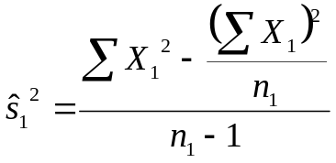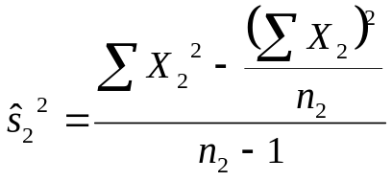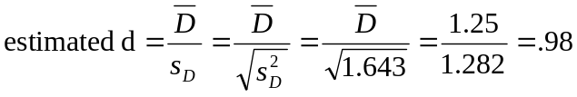

Step 8. Compute r² and write a conclusion.
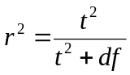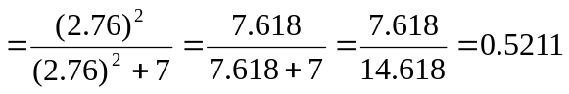

Reinforcement schedule accounts for 52.11% of the variance in the difference scores.

